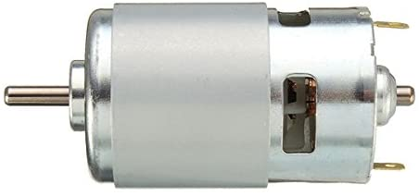
MISURA NUNERO GIRI ALBERI
32x14mm
Cuscinetto 693ZZ
8x3x4 mm
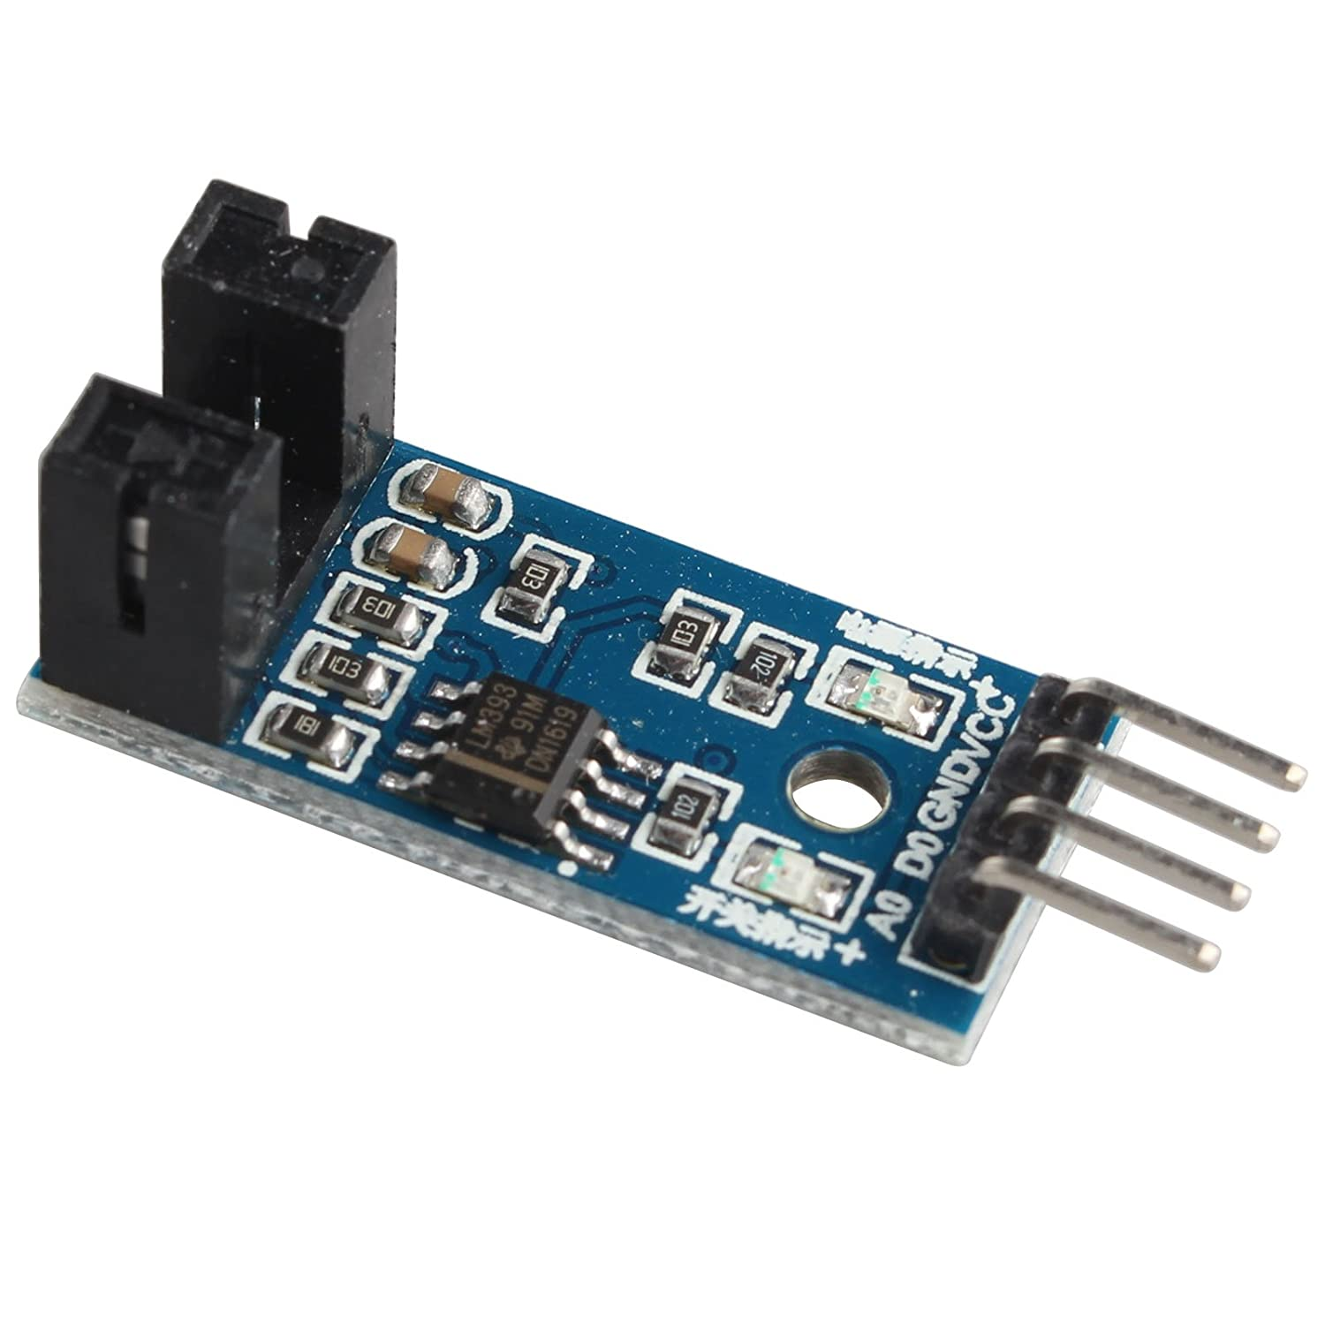

Project#11 Infrared speed sensor module (applied on DIY anemometer)
Mini Motor Speed Sensor -A from Amazon
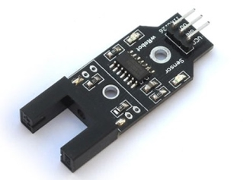
Mini Motor Speed Sensor -B from Amazon
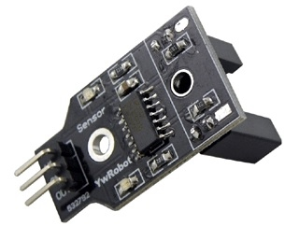
- Motor speed sensor or work piece counting
- Using infrared detection, strong anti-jamming capability
- Schmidt trigger, high sensitivity, stable performance
- 5V Working voltage, black line output low level and white lines output high level
- 74HC14 Hex inverting high performance Schmitt trigger chip
- Photo interrupter: MOCH25A; slotted width : 1 cm

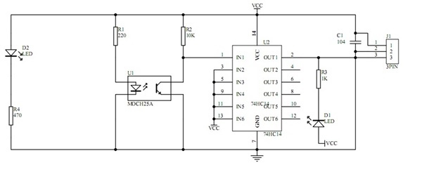

LED-D2 indicates the presence of voltage applied; the LED-D1 monitors operation of the phototransistor.
Optocoupler, U1 - MOCH25A, where the wheel encoder disc is placed. One side was an infrared led, and the other was a phototransistor. If no object block, the phototransistor would conduct; when something blocked the light falling on the transistor it wouldn’t conduct.
Chip U2 - 74HC14 Hex inverting. When there is no object between the photo interrupter will be logical “0”, U2 generates a logical "1" and the LED-D1 is off. During the rotation, the object will block light output from optocoupler will be a logical "1" and U2 is logical “0”, simultaneously, the LED-D1 is on .
Wheel Encoder Disc (Encoder resolution: 20 holes / disc):
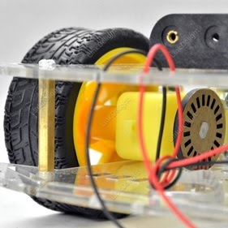
Code:
1  2  3  4  5  6  7  8  9  10  11  12  13  14  15  16  17  18  19  20  21  22  23  24  25  26  27  28  29  30  31  32  33  34  35  36  37  38  39  40  41  42  43  44  45  46  47  48  49 | int encoder_pin = 2; // The pin the encoder is connected  unsigned int rpm; // rpm reading  volatile byte pulses; // number of pulses  unsigned long timeold;  // The number of pulses per revolution  // depends on your index disc!!  unsigned int pulsesperturn = 20;  void counter()  {  //Update count  pulses++;  }  void setup()  {  Serial.begin(9600);  //Use statusPin to flash along with interrupts  pinMode(encoder_pin, INPUT);  //Interrupt 0 is digital pin 2, so that is where the IR detector is connected  //Triggers on FALLING (change from HIGH to LOW)  attachInterrupt(0, counter, FALLING);  // Initialize  pulses = 0;  rpm = 0;  timeold = 0;  }  void loop()  {  if (millis() - timeold >= 1000){ /*Uptade every one second, this will be equal to reading frecuency (Hz).*/  //Don't process interrupts during calculations  detachInterrupt(0);  //Note that this would be 60*1000/(millis() - timeold)*pulses if the interrupt  //happened once per revolution  rpm = (60 * 1000 / pulsesperturn )/ (millis() - timeold)* pulses;  timeold = millis();  pulses = 0;  //Write it out to serial port  Serial.print("RPM = ");  Serial.println(rpm,DEC);  //Restart the interrupt processing  attachInterrupt(0, counter, FALLING);  }  }
Output result as below; it's close to the spec of motor's RPM value =240 @6V
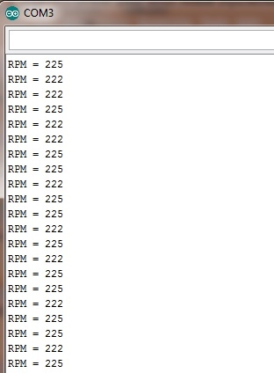

NOTE: Consider Bad Pulses described here
Add 100nF (104) metallized polyester Capacitor to the encoder,
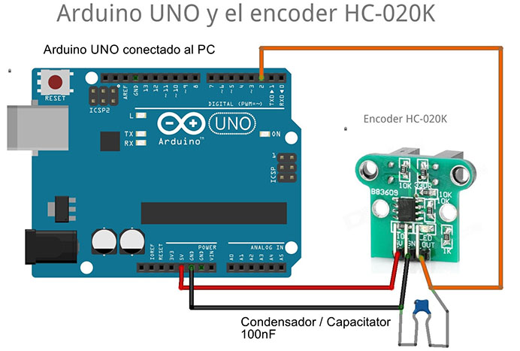
Code:
1  2  3  4  5  6  7  8  9  10  11  12  13  14  15  16  17  18  19  20  21  22  23  24  25  26  27  28  29  30  31  32  33  34 | // https://www.youtube.com/watch?v=9848QETGd_k  // Using HC-020K Photoelectric encoder on the Dual Axis Reducer Motor  // with 100nF capacitor on the encoder  #include <TimerOne.h> // library: https://code.google.com/archive/p/arduino-timerone/downloads  int encoder_pin = 2;  unsigned int counter=0;  void setup() {  Serial.begin(9600);  pinMode(encoder_pin, INPUT);  Timer1.initialize(1000000); // set for 1 sec  attachInterrupt(0,do_count,RISING);  Timer1.attachInterrupt(timerIsr);  }  void loop() {  // put your main code here, to run repeatedly:  }  void do_count() {  counter++;  }  void timerIsr() {  Timer1.detachInterrupt();  Serial.print("Motor Speed: ");  int rotation = (counter/20)*60;  Serial.print(rotation, DEC);  Serial.println(" RPM");  counter=0;  Timer1.attachInterrupt(timerIsr);  }
Result:
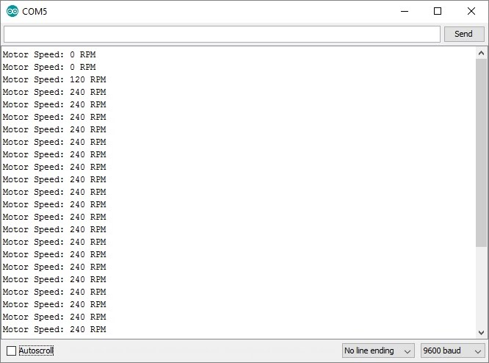
LM393 Comparator IR Speed Sensor Module (FC-03)
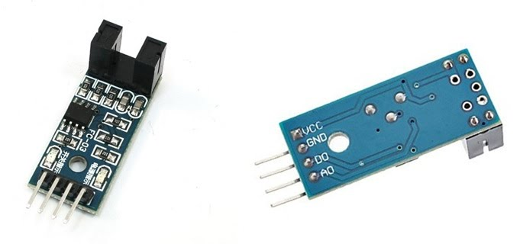
from Amazon
Working Voltage : DC 3.3-5V
Main Chip : LM393
Slotted Width : 5mm
ITR9608 photoelectric switch (not sure, I guessed)
Pins Connection:
VCC: positive power supply 3.3-5V;
GND: Ground;
DO: Output frequency pulses;
AO: analog output, real-time output voltage signal. (not useful)
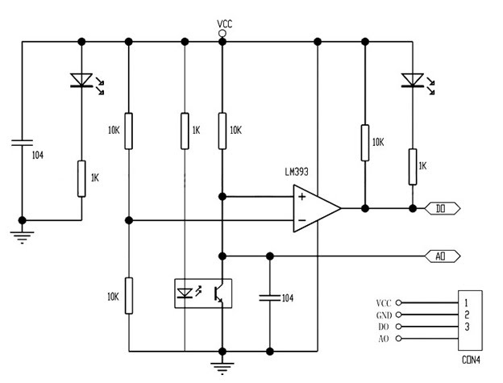

The LED (left) indicates the presence of voltage applied. When there is no object between the photo interrupter, the LED (right) is ON; otherwise is OFF. If slot unobstructed, DO output low; otherwise, DO output high.
Using the same code above, output as below:
Note: I use 3.3V as VCC to get below result; if 5V is used, only get half RPM readings.
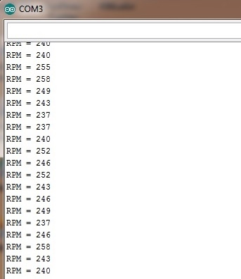

HC-020K Double Speed Measuring Module with Photoelectric Encoders
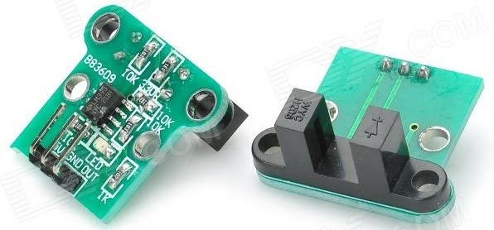
from DX.com or Amazon
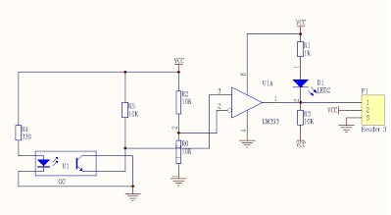

- Module Working Voltage: 4.5-5.5V
- Launch Tube Pressure Drop: Vf=1.6V
- Launch Tube Current: If<20mA
- Signal output: ONE line; TT power level;
- Slotted Width : 6mm
- Chip: LM393

Slotted LM393 Beam Infrared Light Counter Photoelectric Sensor Module
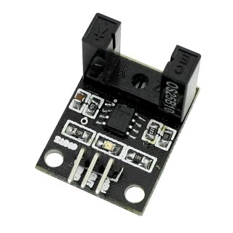
from Amazon
Chip: LM393
Power : DC5V;
Slotted Width : 10mm
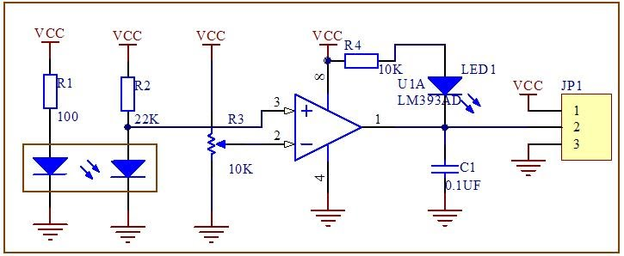

FC-33 Electric Motor Speed Sensor Module
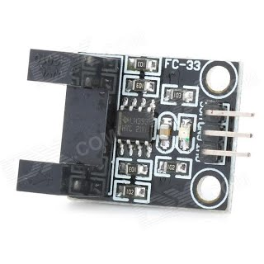
from DX.com
Working voltage: 3.3~5V
Chip: LM393
Slotted Width : 10mm
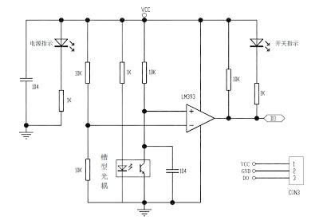
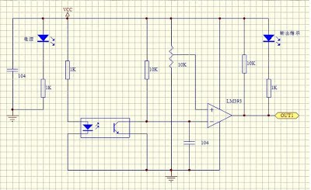

The module can apply to DIY anemometer, it measures the wind flow velocity.
construction detail as https://www.instructables.com/id/DIY-Anemometer-and-Windvane-for-Standalone-Weather/

